Become a patron of the 2020
OCTC Children’s Series and SAVE
Proudly presents
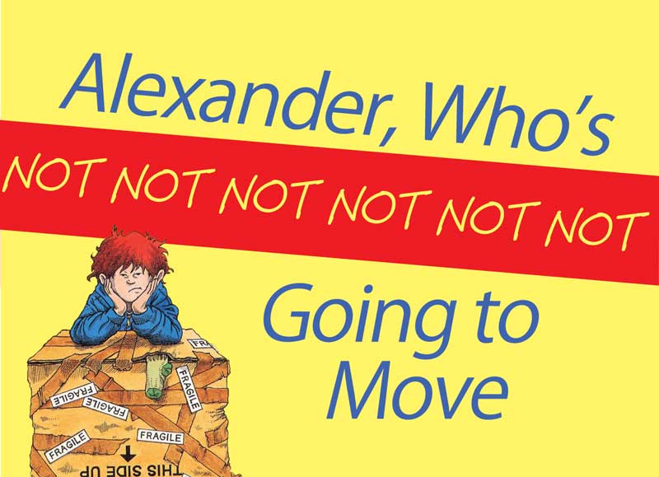

five Great family musicals for one low price
For your payment of $45.00 per person, your membership will include:
- 1 Ticket to the 10:30 AM, June 30th Performance of The Kid Who Ran For President
- 1 Ticket to the 10:30 AM, July 7th Performance of Freckleface Strawberry The Musical
- 1 Ticket to the 10:30 AM, July 14th Performance of Alexander, Who’s Not Not Not …Going To Move
- 1 Ticket to the 10:30 AM, July 21st Performance of Tilly The Trickster
- 1 Ticket to the 10:30 AM, July 28th Performance of Awesome Allie: First Kid Astronaut

This membership special is valued at $45.00 per person, a savings of $15.00 a person!!!

All shows are performed at the historic Ocean City Music Pier
on the Boardwalk between 8th and 9th Streets.
*Shows are subject to change because of Rights/Royalties restrictions
THE KID WHO RAN FOR PRESIDENT - Tuesday, June 30th at 10:30 AM

Judson Moon is 12 years old, and he's running for president of the YOU-nited States! Sound crazy? His best friend and campaign manager, Lane Brainard, with an emphasis on "Brain," is organizing a political campaign that will change the world as we know it! Raising money at a lemonade stand in front of Judson's house, the unlikely candidate gets some media attention that ignites the political voices of children around the nation. But running the country isn't like playing Nintendo; it requires immeasurable responsibility and courage. "Can you imagine a world where YOU were in charge?" But how could the leadership of a 12-year-old kid really handle the decisions of the commander in chief? In the end, it is the voice of a kid that decides the outcome of this exciting musical.

FRECKLEFACE STRAWBERRY THE MUSICAL - Tuesday, July 7th at 10:30 AM
Freckleface Strawberry The Musical, based on the beloved New York Times best-selling book by celebrated actress, Julianne Moore, is a fun and touching family musical. Specifically created to perform for young audiences, families can step inside of the book's pages with Freckleface and friends as they learn to "love the skin they're in."
Freckleface Strawberry will do anything to get rid of her freckles – from scrubbing them with soap to caking on makeup... and even wearing a ski mask to school! Will her schoolmates realize that it's her under the mask? Will Freckleface be brave enough to finally face her complexion in the mirror? With the help of her loveable schoolmates, including an amazingly talented ballerina, a cutie jock, a charming ditz and a totally kooky teacher, Freckleface learns that everyone is different – and that's what makes everyone special.
ALEXANDER, WHO’S NOT NOT NOT NOT NOT NOT GOING TO MOVE - Tuesday, July 14th at 10:30 AM

Alexander has just received some really bad news from his parents. His dad has taken a job in a city a thousand miles away, which means that he and his mom and his dad and his bossy older brothers, Nick and Anthony, are going to have to move to a whole new city. And even though his mom says, "Wait, you'll like it," Alexander already knows that he’ll hate it. He’ll hate it because he’ll never have a best friend like Paul again. And he’ll never have a great sitter like Rachel again. And he’ll never again have his soccer team or his car pool or kids who know him or…Anyway, he can’t bear to leave the people and places he loves, so he decides that he won’t move. First he tries to live with three different neighbors. Then he tries to build a tent so he can live by himself. Then he decides he’ll hide so that his parents’ll never find him, but that doesn’t work out either. While Alexander barricades his bedroom door, his mom and dad and even his brothers find some special ways to make it easier for Alexander to leave. They also help him to understand that home is "where your family is, where you’re with the people who love you best of all." Finally Alexander agrees to leave, but warns that—Do you hear him? He means it!—he’s not not not not not not going to move again! Commissioned and premiered by The John F. Kennedy Center for the Performing Arts.

TILLY THE TRICKSTER - Tuesday, July 21st at 10:30 AM

Molly Shannon has created numerous unforgettable characters on Saturday Night Live and in movies such as Superstar and Never Been Kissed. Now she introduces young readers to her latest hilarious creation, TILLY THE TRICKSTER. Tilly is a mischievous girl who loves nothing more than causing a little trouble. From leaking cups to toothpaste-flavored cookies, Tilly has a trick for everyone: her mom, dad, brother, classmates, and even her teacher. But when the tables are turned and her family does some scheming of its own, will Tilly decide to change her trickster ways?
AWESOME ALLIE: FIRST KID ASTRONAUT- Tuesday, July 28th at 10:30 AM

Allie was just your typical eight-year-old girl from Skokie, Illinois, until one day she was chosen for a very special mission. At the farthest edges of our solar system, a space alien lands on Pluto looking for something very important from Earth. But it won’t speak with the President. It claims it won’t speak with anyone. Anyone, that is, except Awesome Allie. Called from across the sky and tapped by the President himself, Allie soon sets out in her dance-powered spaceship on a journey through the stars, soaring from Earth to Pluto with only a trusty, talking dog named Captain Chaos by her side. Along the way, she’ll meet unlikely challenges and unlikelier friends, from the disco dancing land rover stranded on Mars, to the world’s smartest supercomputer, PAL 9000. She’ll learn the order of the planets and lots of fun facts about the solar system, and she’ll need the whole audience’s help if she’s going to dance her ship all the way to Pluto. But what does this Alien want? What is it that’s worth crossing the entire solar system to find? Allie’s about to discover that friendship just might be the most important thing in the whole universe—but only the audience can help her figure it out!
OCTC Children’s Theatre Series Membership Form

Name: ____________________________________________

Mailing address: ____________________________________________

____________________________________________
** Please note tickets will be mailed to the above address by May 15, 2020

Email address: ____________________________________________

Phone: ____________________________________________

Number of Memberships _____ x $45.00 = Total due: _______

Seating Preference: _________________________________________
*Please note: seating is on a first come, first serve basis & the preference you indicated may not be available

- Checks should be made payable to the Ocean City Theatre Company.
- All sales final! No refunds or exchanges.
- Tickets are non-transferable and non-refundable.
- No special membership rates for Seniors Citizens, Students or Kids.
- To ensure you sit with friends/family, please use one membership form for everyone in your party.
- The 2020 Subscription Package must be purchased before May 1, 2020.
- General ticket sales start February 3, 2020

Mail Check and Order form to:
OCTC
1501 West Ave.
Ocean City, NJ 08226

