6 Great Reasons Why You Should
Advertise in our 2020 Summer Playbill

- Reach a desirable, captive audience of over 4,000 patrons over the course of our summer season! Theatre playbills are keepsakes that are typically read cover-to-cover. Your ad will be seen by a highly desirable demographic group of potential customers per show!

- Who Are Theatre-goers and playbill readers? Median age: 44 Annual Income: (household average) $119,150/yr. Investments: 85% own investments Automobiles: 69% own two or more cars Dining Out: 78% dine out before or after the theatre Occupation: 68% Professional, Managerial and Executive Time spent reading theatre playbills: In theatre: 10 min./At home: 11 min.

- High-quality advertising because of first-rate printing and complimentary full color printing. Also, ad space is limited so your company will not get lost in a cluttered, over sold publication.

- Enjoy a measure of goodwill that you can’t get from other forms of advertising! Our patrons, company members and trustees recognize that Playbill advertisers provide vital support to the Greater Ocean City Theatre Co. and reward those companies with their patronage and business. In addition, your advertising dollars directly support the artistic and educational programs of a theatre that generates tourism, cultural value and local economic activity.

- Geographic reach! The theatre’s audience is drawn from throughout Greater Delaware Valley region and is made up of “local residents” and visitors to America’s Greatest Family Resort.

- For one low price your ad will appear in both of our Summer 2020 Broadway Musicals! Special incentive…If you turn in your payment and artwork by May 1, 2020 your ad will be included in the playbill for BROADWAY ON THE OC BOARDWALK taking place at the Music Pier on June 24, 2020.
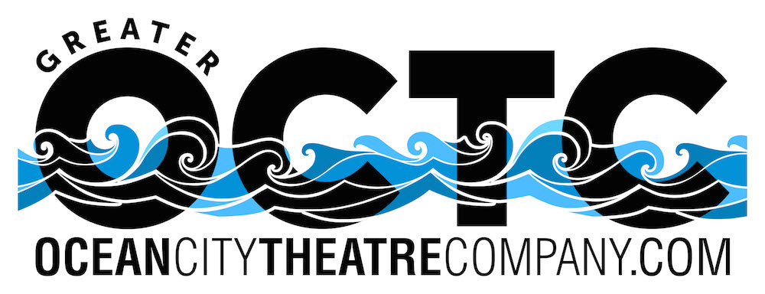
The Greater Ocean City Theatre Company is a 501(c)3 not-for-profit theatre dedicated to promoting professional Broadway style musical theatre and educational arts opportunities for youth.

2020 Summer Playbill Advertising Order Form
Deadline for all Ad Copy is June 12, 2020

Business: ____________________________________________

Contact Name: ________________________________________

Phone: ______________________________________________

Email: _______________________________________________

Address: _____________________________________________

Remember: Two Great Shows, One Great Price!

Circle one: Full Page Color Ad $500 Half Page Color Ad $250

Please email your camera-ready ad to info@oceancitytheatrecompany.com

Half Page Color
5” wide X 3 3/4“ high
*horizontal only

Full Page Color
5” wide X 8“ high

Mail this form and check to:
Ocean City Theatre Company, 1501 West Avenue, Ocean City, NJ 08226
Email your PDF ad to:
info@oceancitytheatrecompany.com

Please make checks payable to Ocean City Theatre Company

Final deadline for ALL ad copy is June 12, 2020.

Remember if you turn in your ad copy and payment by May 1st your ad will appear free of charge in our Broadway on the OC Boardwalk Playbill!

Questions? Call 609-398-1118 or email info@oceancitytheatrecompany.com

Thank you in advance for your support!!!

