Become a patron of the 2022
OCTC Children’s Series and SAVE
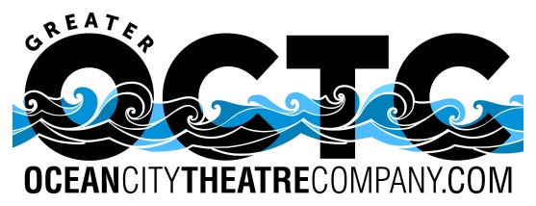
Proudly presents
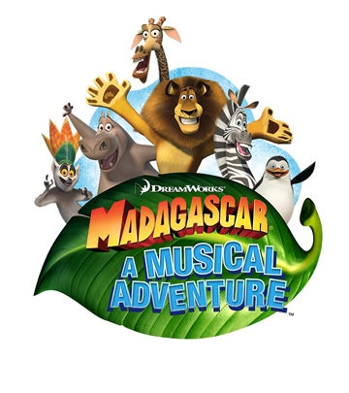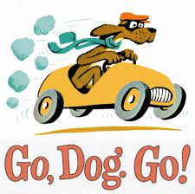
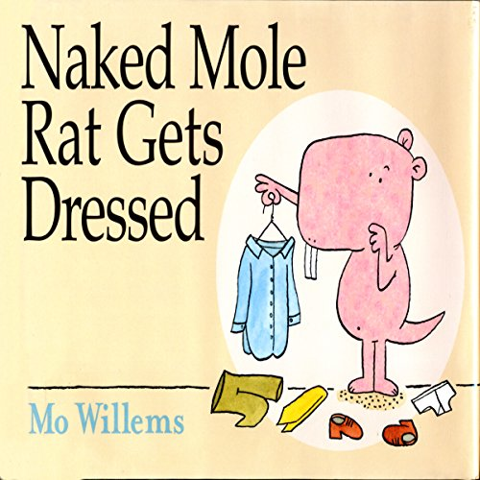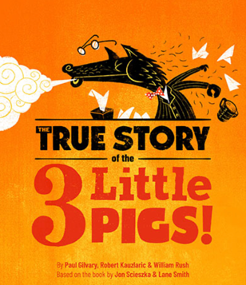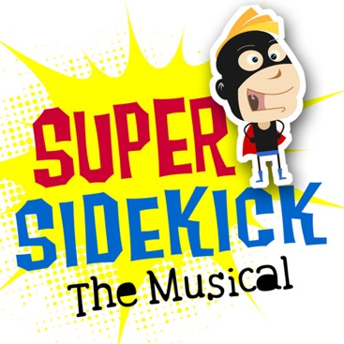

five Great family musicals for one low price
For your payment of $45.00 per person, your membership will include:
- 1 Ticket to the 10:30 AM, July 5th Performance of Madagascar A Musical Adventure
- 1 Ticket to the 10:30 AM, July 12th Performance of Go Dog Go
- 1 Ticket to the 10:30 AM, July 19th Performance of Naked Mole Rat Gets Dressed
- 1 Ticket to the 10:30 AM, July 26th Performance of The True Story Of The 3 Little Pigs
- 1 Ticket to the 10:30 AM, August 2nd Performance of Super Sidekick The Musical

This membership special is valued at $45.00 per person, a savings of $15.00 a person!!!

All shows are performed at the historic Ocean City Music Pier
on the Boardwalk between 8th and 9th Streets.
*Shows are subject to change because of Rights/Royalties restrictions
MADAGASCAR A MUSICAL ADVENTURE - Tuesday, July 5th at 10:30 AM
Join Alex the Lion, Marty the Zebra, Melman the Giraffe, Gloria the hip hip Hippo and, of course, those hilarious, plotting penguins as they bound onto your stage in the musical adventure of a lifetime. Based on the smash DreamWorks animated motion picture, Madagascar – A Musical Adventure follows all of your favorite crack-a-lackin’ friends as they escape from their home in New York’s Central Park Zoo and find themselves on an unexpected journey to the madcap world of King Julien’s Madagascar.
Alex the lion is the king of the urban jungle, the main attraction at New York's Central Park Zoo. He and his best friends – Marty the zebra, Melman the giraffe and Gloria the hippo – have spent their whole lives in blissful captivity before an admiring public and with regular meals provided for them. Not content to leave well enough alone, Marty lets his curiosity get the better of him and makes his escape – with the help of some prodigious penguins – to explore the world.
Filled with outlandish characters, adventure galore and an upbeat score, Madagascar will leave audiences with no choice but to “Move It, Move It!”
_________________________________________________________________________________________________

GO DOG GO - Tuesday, July 12th at 10:30 AM

P.D. Eastman’s classic children’s book comes to life on stage in an exploration of movement, color and space. The dogs delve into life with gusto, creating a visual spectacle for the audience to feast upon. They snorkel. They howl at the moon. They ride a ferris wheel. They sing and dance and climb trees. This is a rollicking free-for-all of chicanine-ery. A big and little musical world of doggy fun. Like a pop-up book that comes to life – and never stops.
_______________________________________________________________________________________________

NAKED MOLE RAT GETS DRESSES - Tuesday, July 19th at 10:30 AM
Naked Mole Rat Gets Dressed: The Rock Experience is a rock 'n roll parable with a significant message for today's audiences, based on the hit children's book by Mo Willems. Wilbur and all his fellow naked mole rats in the Tunnel have always been, well...naked. Wondering what other possibilities are out there, Wilbur discovers a love for clothing and style. When word of his new passion turns the Tunnel upside down, he proves to everyone that there's no need to be just like everyone else.
A special lesson and rock show all in one, Naked Mole Rat Gets Dressed has energetic songs, quirky characters, and a story unlike any other. Don't be afraid to stand out!
_______________________________________________________________________________________________
THE TRUE STORY OF THE 3 LITTLE PIGS- Tuesday, July 26th at 10:30 AM

There are two sides to every story, and when the Big, Bad Wolf takes the stand in Piggsylvania’s Trial of the Century, he finally gets his say. But whether he’ll get a fair trial in a corrupt piggy court is anyone’s guess. Will the pigs’ splashy puppet show make a puppet out of justice, or is the wolf’s catchy song and dance about a sneeze gone wrong all razzle-dazzle? Enter the jury box and decide the fate of Big ‘n’ Bad in this musical adaptation of the hit children’s book.

SUPER SIDEKICK THE MUSICAL- Tuesday, August 2nd at 10:30 AM

When famous superhero Blackjack the Bold is kidnapped by an evil sorcerer, it's up to his assistant Inky to step up and save the day! Little does he know that he'll also have to contend with Ninja Koalas, dark caves, secret weapons, and an abducted princess who's considerably braver than he is. Colorful characters, witty humor, and an upbeat catchy score make Super Sidekick: The Musical a treat for young audiences.

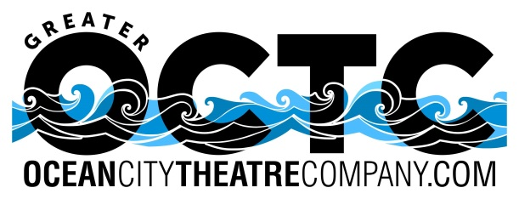
OCTC Children’s Theatre Series Membership Form

Name: ____________________________________________

Mailing address: ____________________________________________

____________________________________________
** Please note tickets will be mailed to the above address by May 15, 2022

Email address: ____________________________________________

Phone: ____________________________________________

Number of Memberships _____ x $45.00 = Total due: _______

Seating Preference: _________________________________________
*Please note: seating is on a first come, first serve basis & the preference you indicated may not be available

- Checks should be made payable to the Ocean City Theatre Company.
- All sales final! No refunds or exchanges.
- Tickets are non-transferable and non-refundable.
- No special membership rates for Seniors Citizens, Students or Kids.
- To ensure you sit with friends/family, please use one membership form for everyone in your party.
- The 2022 Subscription Package must be purchased before May 1, 2022.
- General ticket sales start February 3, 2022

Mail Check and Order form to:
OCTC
1501 West Ave.
Ocean City, NJ 08226

